Retail Analysis

Primary Data Analysisi

Data Cleaning and Data Inspection

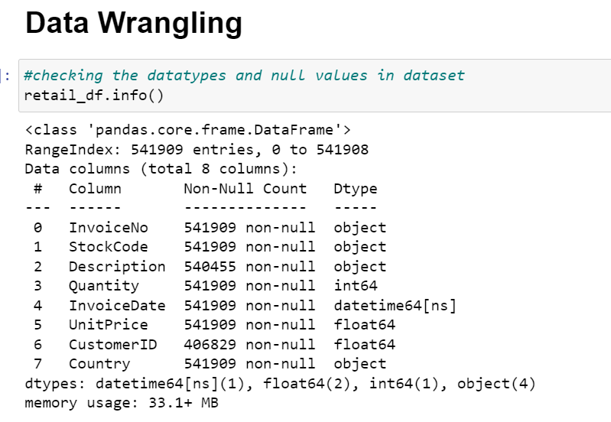

Feature Engineering

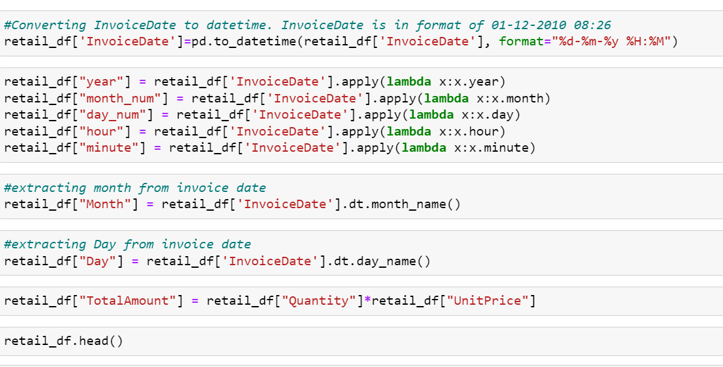

Hierarchical Clustering



